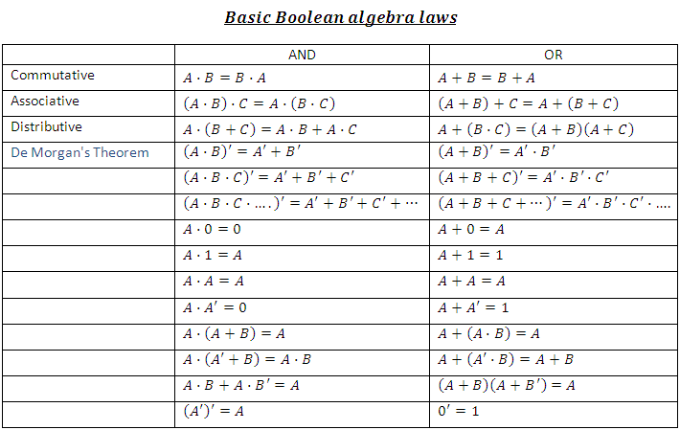Xc

Identity Law

Null Law

Idempton Law

Inverse Law

**Slide 27 of 11**